Part F – Calculate the Optimum Predictor in MATLAB

After calculating a_opt and finding MSE we get these values:
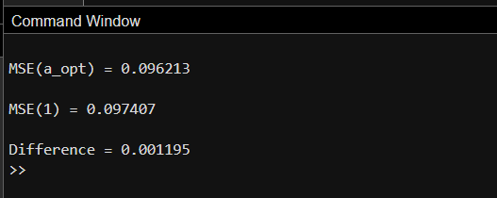

So a_opt has a 1.22% improvement over a = 1.
Question:
Calculate the prediction error using a_opt and compare its MSE with the MSE for a = 1. Is the difference significant? Explain based on the characteristics of the signal.

Answer:
No, the difference is not significant. This is because the signal changes gradually and has strong correlation between adjacent samples. Therefore, using x[n-1] with a = 1 already provides a good prediction, so optimizing the coefficient only produces a small improvement in the MSE.

